VLAN TruNking AND ACCESS PORTS

Q1. In Cisco Packet Tracer, configure two switches (Switch1 and Switch2) and connect them with a crossover cable. Set the FastEthernet0/1 port on both switches as trunk ports using the 802.1Q protocol.
Ans. I have configured 2 switches with switchport mode trunk and they are using 802.1Q protocol
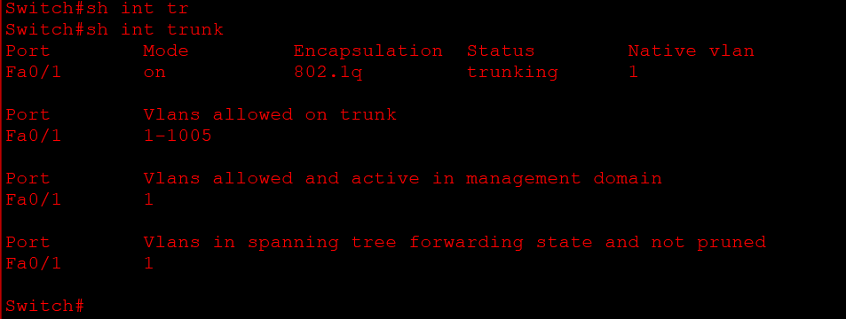
Q2. Create three VLANs (10, 20, 30) on both switches and assign FastEthernet0/2, 0/3, and 0/4 on Switch1 to VLAN 10, 20, and 30 respectively as access ports.
Ans. I have connected two switches and on one switch I have assigned ports to different vlans
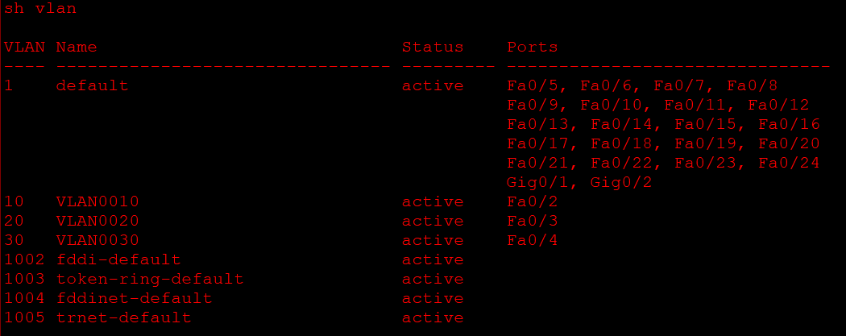
Q3. Connect three PCs to Switch1 on ports assigned to VLAN 10, 20, and 30. Verify that PCs in different VLANs cannot communicate with each other, but can communicate with other PCs in the same VLAN.
Ans. Yes I have verified that the pc on the vlan 10 is communicating with the other switch pc on vlan 10 but not communicating with the pc’s on different vlan.
Q4. Change the trunk encapsulation on the trunk link between Switch1 and Switch2 from 802.1Q to ISL, and test if VLAN traffic still passes between the switches. Hint: Use the 'switchport trunk encapsulation isl' command before setting the port to trunk mode.
Ans. Objective: To change the trunk encapsulation between Switch1 and Switch2 from 802.1Q to ISL and verify VLAN connectivity.
Step 1: Configure ISL on Switch1
Switch1> enable
Switch1# configure terminal
Switch1(config)# interface fa0/1
Switch1(config-if)# switchport trunk encapsulation isl
Switch1(config-if)# switchport mode trunk
Switch1(config-if)# end
Step 2: Configure ISL on Switch2
Switch2> enable
Switch2# configure terminal
Switch2(config)# interface fa0/1
Switch2(config-if)# switchport trunk encapsulation isl
Switch2(config-if)# switchport mode trunk
Switch2(config-if)# end
Step 3: Verify Trunk Configuration
Run the following command on both switches:
Switch# show interfaces trunk
If supported, the encapsulation should display ISL.
Step 4: Test VLAN Connectivity
- Connect PCs to the same VLAN on both switches.
- Use the ping command to test connectivity.
- If both switches support ISL and are configured correctly, VLAN traffic should pass successfully.
Observation
- ISL allows VLAN traffic between compatible Cisco switches.
- Both ends of the trunk must use matching encapsulation.
- A mismatch between ISL and 802.1Q prevents normal VLAN communication.

Q5. Simulate a scenario where a new port on Switch2 (FastEthernet0/5) is accidentally set as a trunk port instead of an access port for VLAN 20. Observe and explain the impact on connectivity for a PC connected to that port.
Ans. Objective: To observe the impact of accidentally configuring Switch2 Fa0/5 as a trunk port instead of an access port for VLAN 20.
Step 1: Configure the Incorrect Trunk Port
Open Switch2 CLI and enter:
Switch2> enable
Switch2# configure terminal
Switch2(config)# interface fa0/5
Switch2(config-if)# switchport mode trunk
Switch2(config-if)# end
Step 2: Verify the Configuration
Switch2# show interfaces trunk
Switch2# show vlan brief
These commands help identify whether Fa0/5 is configured as a trunk instead of an access port.
Step 3: Test Connectivity
- Connect a PC to Fa0/5 on Switch2.
- Assign the PC an IP address belonging to VLAN 20's subnet.
- Ping another PC connected to VLAN 20.
- Observe whether communication is successful.
Step 4: Observation
- The PC may fail to communicate with other VLAN 20 devices.
- The trunk port carries VLAN-tagged traffic, while a normal PC sends untagged frames.
- With the default native VLAN 1, untagged PC traffic is assigned to VLAN 1 instead of VLAN 20.
Step 5: Correct the Configuration
Switch2# configure terminal
Switch2(config)# interface fa0/5
Switch2(config-if)# switchport mode access
Switch2(config-if)# switchport access vlan 20
Switch2(config-if)# end
Conclusion: An incorrectly configured trunk port can cause connectivity problems because the PC's traffic may be placed in the wrong VLAN. After changing Fa0/5 to an access port in VLAN 20, normal communication with other VLAN 20 devices can be restored.

